Copyright for test papers and marking guides remains with West Australian Test Papers.
Test papers may only be reproduced within the purchasing school according to the advertised Conditions of Sale.
Test papers should be withdrawn after use and stored securely in the school until Friday June 12th 2020.


MATHEMATICS
SPECIALIST
UNIT 3

Semester One

2020

SOLUTIONS

Calculator−free Solutions

1. (a) $g\left(f\right)=\frac{2}{f-2}=\frac{2}{\sqrt{4-x } - 2}$
(b) $D_{x}=\left\{x∈R:x≤4 ˄ x≠0\right\}$
$R_{y}=\left\{y∈R:y>0 ˅ y≤-1\right\}$
(c) No, because $f^{-1}\left(x\right)$ does not exist for $x<0$. [7]

2. (a) $λ=3$ and $μ=1$ given, then:
$\left(\begin{matrix}3+3 \\ 1+3 \\ -6\end{matrix}\right)=\left(\begin{matrix}a \\ b \\ c\end{matrix}\right)+1×\left(\begin{matrix}4 \\ -2 \\ 1\end{matrix}\right) → \left(\begin{matrix}a \\ b \\ c\end{matrix}\right)=\left(\begin{matrix}2 \\ 6 \\ -7\end{matrix}\right)$
$∴\vec{OP}=\left(\begin{matrix}6 \\ 4 \\ -6\end{matrix}\right) → \left|OP\right|=\left|\begin{matrix}6 \\ 4 \\ -6\end{matrix}\right|=2\sqrt{22} units$
(b) $d_{3}=d_{1}×d_{2}=\left(\begin{matrix}1 \\ 1 \\ -2\end{matrix}\right)×\left(\begin{matrix}4 \\ -2 \\ 1\end{matrix}\right)=\left(\begin{matrix}-3 \\ -9 \\ -6\end{matrix}\right)=-3\left(\begin{matrix}1 \\ 3 \\ 2\end{matrix}\right)$
answers must be parallel to $〈1, 3, 2〉$
$∴L_{3}: r=\left(\begin{matrix}6 \\ 4 \\ -6\end{matrix}\right)+α\left(\begin{matrix}1 \\ 3 \\ 2\end{matrix}\right)$
$∴n=d_{3}=\left(\begin{matrix}1 \\ 3 \\ 2\end{matrix}\right) → k=n∙\vec{OP}=\left(\begin{matrix}1 \\ 3 \\ 2\end{matrix}\right)∙\left(\begin{matrix}6 \\ 4 \\ -6\end{matrix}\right)=6+12-12=6$
$∴r∙\left(\begin{matrix}1 \\ 3 \\ 2\end{matrix}\right)=6 → x+3y+2z=6$ [9]

3. (a) (i) $\frac{\overline{-1+i}}{{\left(2+i\right)}^{2}}=\frac{-1-i}{3+4i}×\frac{3-4i}{3-4i}=\frac{-7+i}{9+16}=\frac{-7}{25}+\frac{i}{25}$
(ii) ${\left(\frac{1}{\sqrt{2}}-\frac{i}{\sqrt{2}}\right)}^{2020}={\left[\operatorname{cis}\left(-\frac{π}{4}\right)\right]}^{2020}$
$={\left[\operatorname{cis}\left(-\frac{π}{4}\right) \right]}^{2016}×{\left[\operatorname{cis}\left(-\frac{π}{4}\right)\right]}^{4}$
$=1×\cos\left(-π\right)=-1+0i$
(b) (i) $z=1+i$ is a root of $f\left(z\right)$
$∴f\left(1+i\right)={\left(1+i\right)}^{3}-5{\left(1+i\right)}^{2}+8\left(1+i\right)-6$
$=-2+2i-10i+2+8i=0+0i$
$∴\left(z-1-i\right)$ is a root of $f\left(z\right)$ as per the factor theorem.
(ii) Since the coefficients of $f\left(z\right)$ are real, then $\overline{z}=1-i$ is
also as root.
$∴\left(z-1-i\right)\left(z-1+i\right)\left(z-w\right)=0$
$\left(z^{2}-2z+2\right)\left(z-w\right)=0 → w=3$
Solutions are $z=3, 1±i$ [12]
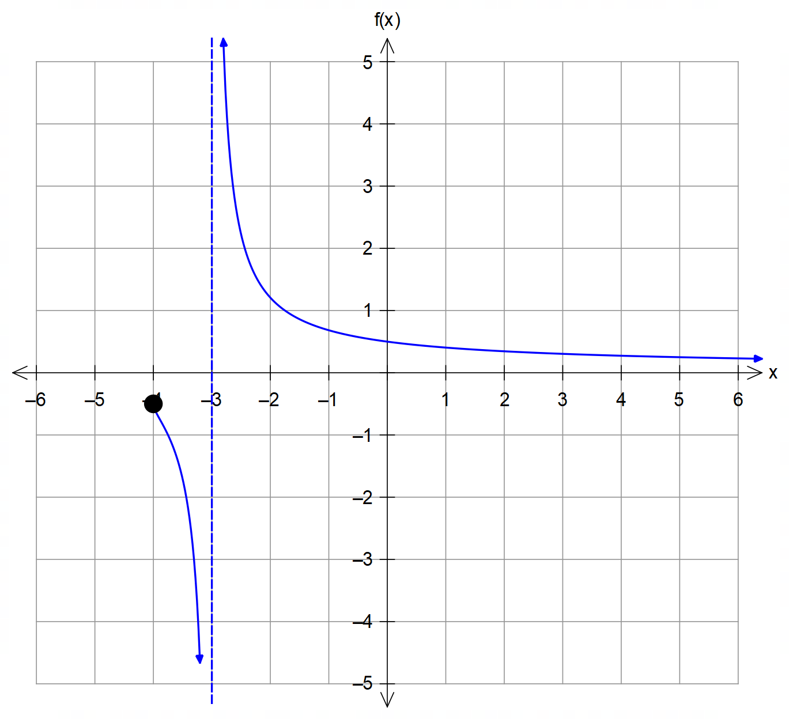4. (a)

asymptote y = 0
and a pole x=-3

behaviour on either side of the pole.

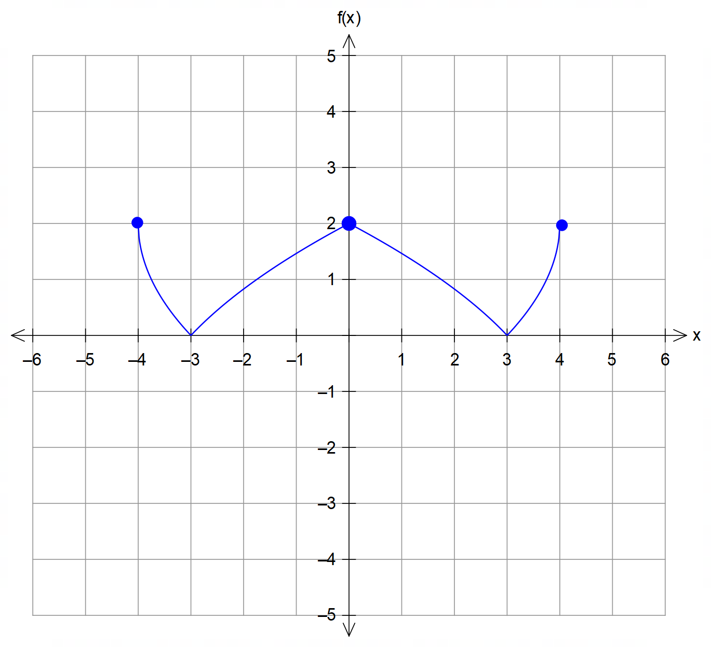
(b)
roots $x=±3$
y-intercept y=2

symmetry and
curvature

(c) $k=-3$
$D_{x}=\left\{x∈R:x≥0\right\}$
$R_{y}=\left\{y∈R:y≥-3\right\}$ [9]

5. (a) $x=3, y=-1, z=4$
(any algebraic method or matrix method accepted)

5. (b) The normal vectors to the three planes are $\left(\begin{matrix}1 \\ 1 \\ 1\end{matrix}\right),\left(\begin{matrix}2 \\ 0 \\ 1\end{matrix}\right)$ and $\left(\begin{matrix}0 \\ 1 \\ k\end{matrix}\right).$
Solutions do not exist for $k=\frac{1}{2}$
which is when the three planes are non-parallel but do not
intersect at a single point in space.
Solutions exist for $k≠\frac{1}{2}$ [6]

6. (a) $E\left(-2, -5, -2\right)$
(b) $\frac{V_{I}}{V_{tot}}×100\%=\frac{2×3×4}{4×8×6}=\frac{100}{8}=\frac{25}{2}=12.5\%$
(c) centre = midpoint $=\left(0, -1, 1\right)$
radius $=\frac{1}{2}\left|HB\right|=\frac{1}{2}\left|\begin{matrix}4 \\ -8 \\ -6\end{matrix}\right|=\sqrt{29}$
$∴\left|r+j-k\right|=\sqrt{29}$ [6]

7. Solutions must satisfy:
${\left[\operatorname{cis}\left(\frac{π}{3}\right)\right]}^{n}={\left[\operatorname{cis}\left(π\right)\right]}^{n}=-1$
$∴\operatorname{cis}\left(\frac{nπ}{3}\right)=\operatorname{cis}\left(nπ\right)=-1$
from symmetry, the roots must be equally spaced at intervals
of $\frac{2π}{3},\frac{π}{3}, …etc$ therefore $n=3, 9, 15, …, 3\left(2k+1\right), k=0, 1, 2, 3, …$ [4]
(it must be an odd multiple of 3)
(any explanation based on symmetry is acceptable)

Calculator−Assumed Solutions

8. Discontinuities at $x=2, 6 → c=-2 d=-6, or c=-6, d=-2$
Oblique asymptote is given by $y=ax+b=-\frac{1}{2}x+1$
$∴a=-\frac{1}{2} b=1$
$f\left(x\right)=-\frac{x}{2}+1+\frac{k}{\left(x-2\right)\left(x-6\right)}$ using the point $\left(4,-2\right)$ given:
$-2=-2+1+\frac{k}{-4} → k=4$ [5]

9. (a) $\vec{AB}=\left(\begin{matrix}-3 \\ 3 \\ 3\end{matrix}\right)$ and $\vec{AC}=\left(\begin{matrix}1 \\ 5 \\ 6\end{matrix}\right)$
CAS $→⦞BAC≈42.84°=43°$
(b) Let $r=\vec{OA}+λ\vec{AB}+μ\vec{AC}=\left(\begin{matrix}1 \\ -2 \\ -1\end{matrix}\right)+λ\left(\begin{matrix}-3 \\ 3 \\ 3\end{matrix}\right)+μ\left(\begin{matrix}1 \\ 5 \\ 6\end{matrix}\right)$
(Other solutions exist)
(c) (i) $\vec{AB}×\vec{AC}=\left(\begin{matrix}3 \\ 21 \\ -18\end{matrix}\right)=β\left(\begin{matrix}m \\ 7 \\ n\end{matrix}\right)$
$∴β=3 → m=1 n=-6$ as required
(ii) Normal equation of the plane needed:
$n=\left(\begin{matrix}1 \\ 7 \\ -6\end{matrix}\right) → k=\vec{OA}∙n=\left(\begin{matrix}1 \\ -2 \\ -1\end{matrix}\right)∙\left(\begin{matrix}1 \\ 7 \\ -6\end{matrix}\right)=-7$
$∴r∙\left(\begin{matrix}1 \\ 7 \\ -6\end{matrix}\right)=-7$
$α\left(\begin{matrix}1 \\ 7 \\ -6\end{matrix}\right)∙\left(\begin{matrix}1 \\ 7 \\ -6\end{matrix}\right)=-7 → α=-\frac{7}{86}$
$∴\vec{OP}=〈-\frac{7}{86}, -\frac{49}{86},\frac{42}{86}〉$
(d) Since L in (c)(ii) passes through the origin, then $\vec{OP}$ is
the position vector of the point of shortest distance from O.
$∴\left|OP\right|=\frac{7}{86}\left|\begin{matrix}1 \\ 7 \\ -6\end{matrix}\right|=\frac{7}{86}\sqrt{86}≈0.75 units$ [10]

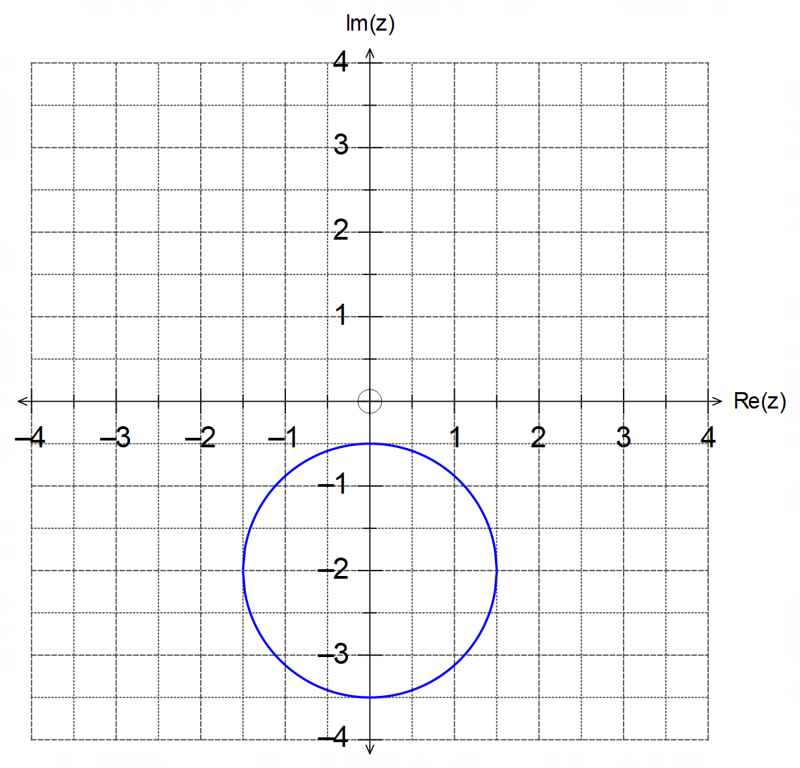10. (a) (i)
circle

centred at (0,-2)

radius of 1.5 units

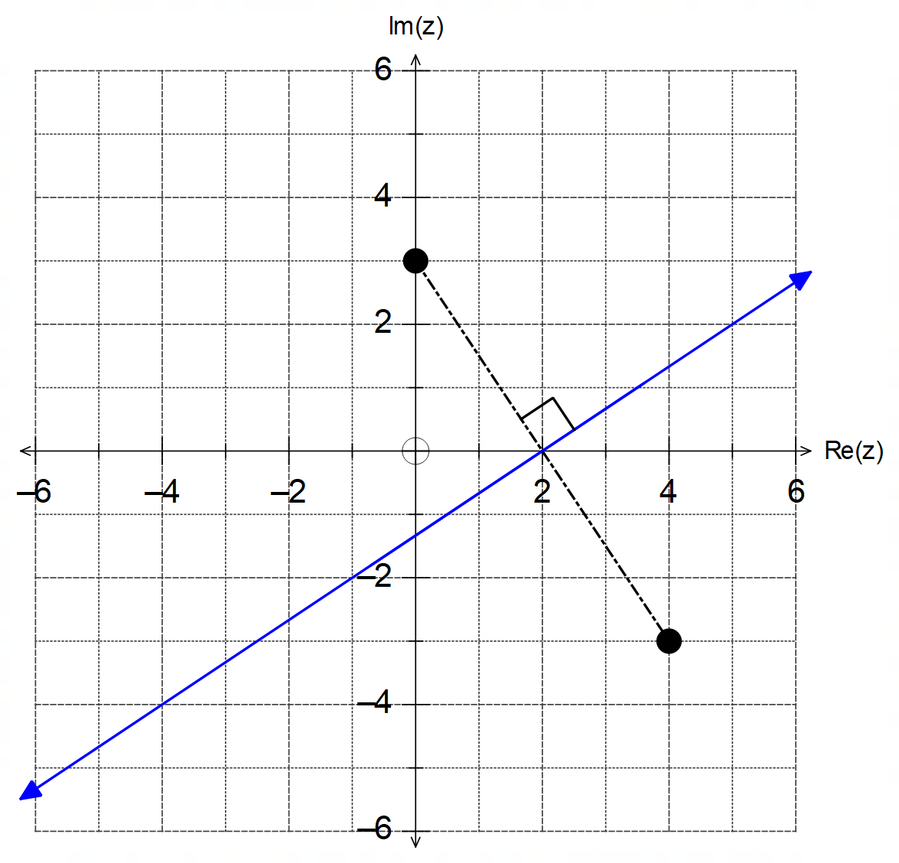
(ii)
line $y=\frac{2x}{3}-\frac{4}{3}$
or passes through
the points (2,0)
and (-1, -2)

perpendicular
bisector between
points given

(b) $z-i$ is a translation of 1 unit down.
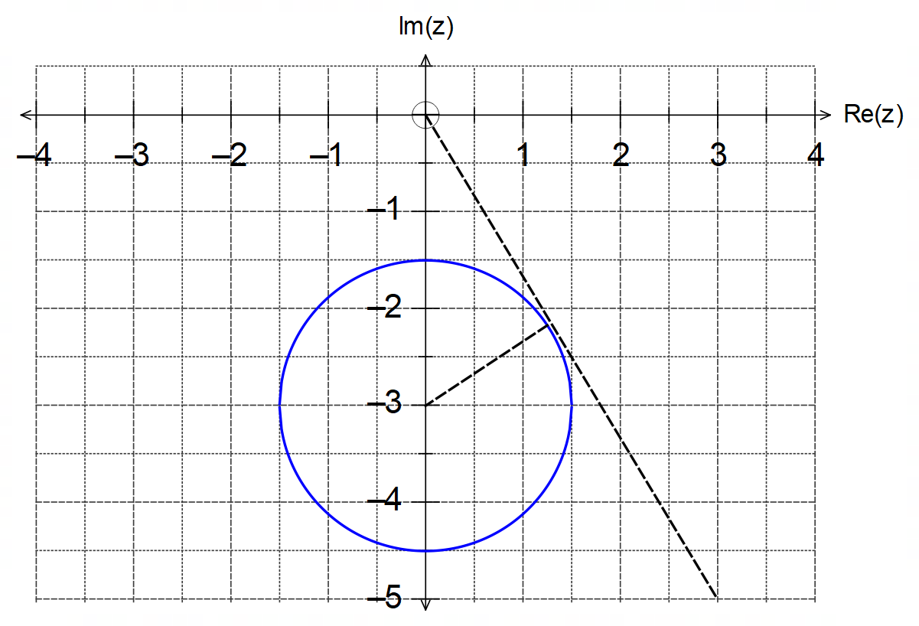

From diagram: ${\left|z\right|}_{max}=\left|-3\right|+\left|\frac{3}{2}\right|=4.5 units$
and ${\arg\left(z\right)}_{max}$ occurs in 4th quadrant:
${\arg\left(z\right)}_{max}=-π+\sin^{-1}\left(\frac{1.5}{3}\right)=-\frac{π}{3}$ [10]

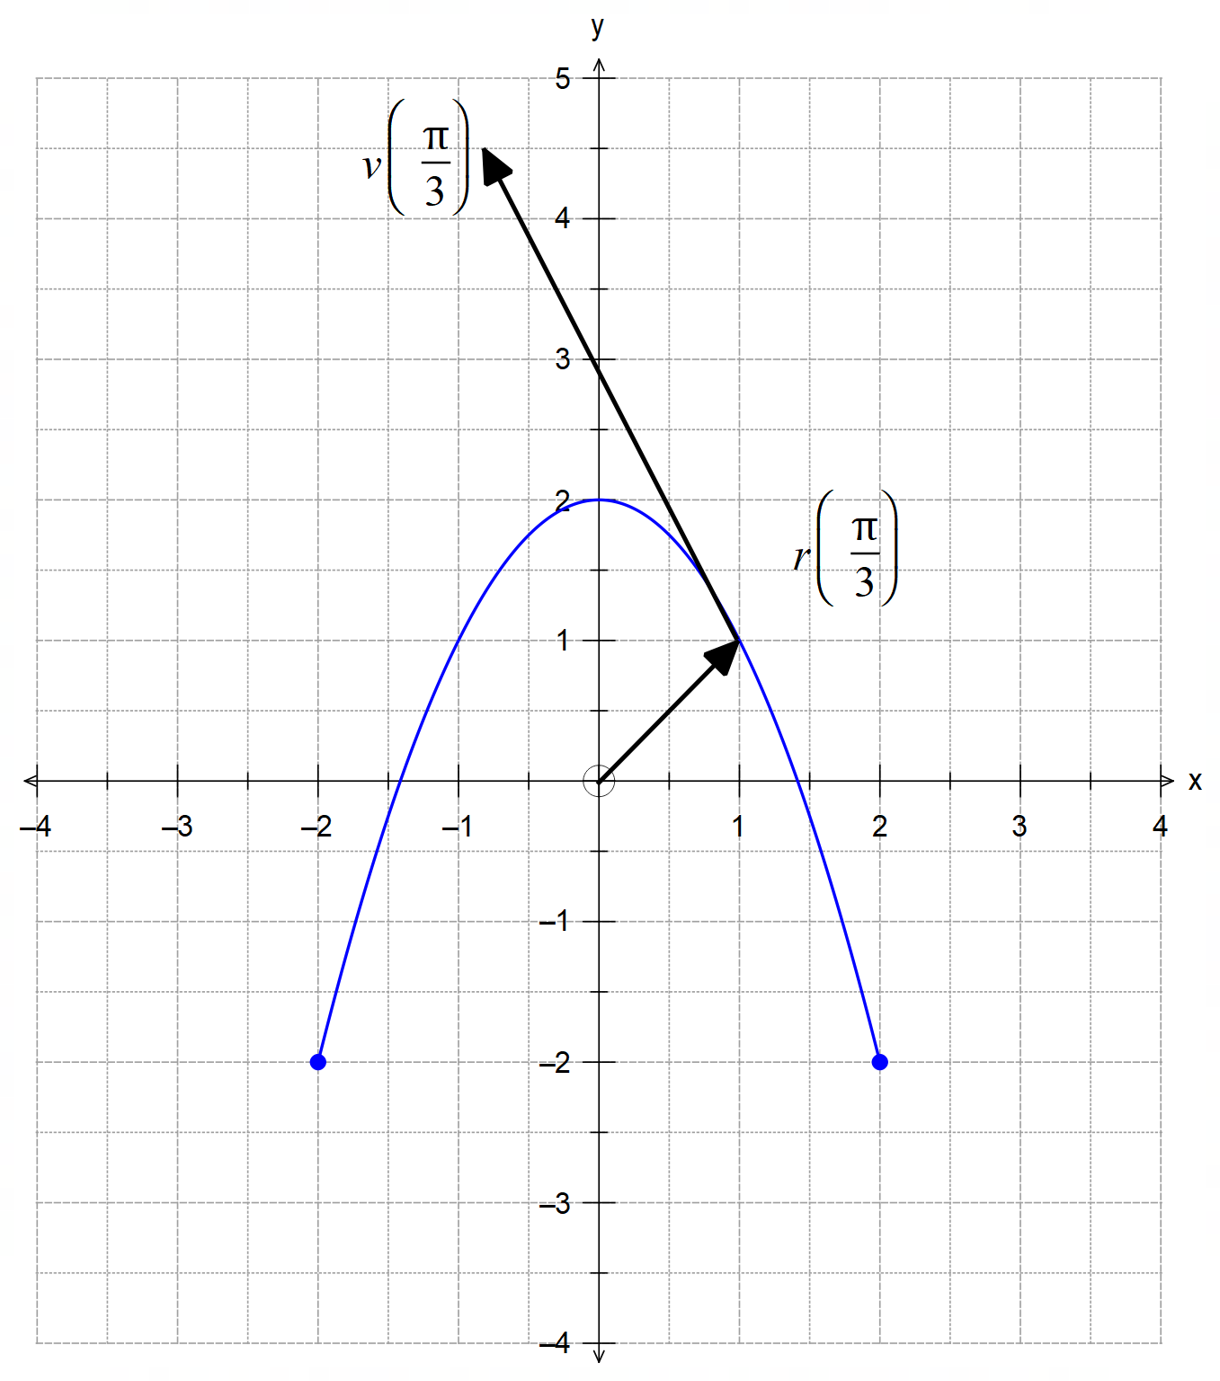11. (a)
(a)
parabola
$y=2-x^{2}$

restricted domain
$-2≤x≤2$

(c)
position vector
$〈1, 1〉$

velocity vector
$〈-1.7, 3.5〉$ from (1,1)

(b) $t=2π minutes$
(c) $x=2\cos\left(t\right)=1 → t=\frac{π}{3} min$
$r\left(\frac{π}{3}\right)=\left(\begin{matrix}2\cos\left(π/3\right) \\ -2\cos\left({2π}/3\right)\end{matrix}\right)=\left(\begin{matrix}1 \\ 1\end{matrix}\right)$
$v\left(t\right)=\left(\begin{matrix}-2\sin\left(t\right) \\ 4\sin\left(2t\right)\end{matrix}\right) → v\left(\frac{π}{3}\right)=\left(\begin{matrix}-2\sin\left(π/3\right) \\ 4\sin\left({2π}/3\right)\end{matrix}\right)≈\left(\begin{matrix}-1.7 \\ 3.5\end{matrix}\right)$
(d) $a\left(t\right)=\left(\begin{matrix}-2\cos\left(t\right) \\ 8\cos\left(2t\right)\end{matrix}\right)$
$a\left(\frac{π}{6}\right)=\left(\begin{matrix}-2\cos\left(π/6\right) \\ 8\cos\left(π/3\right)\end{matrix}\right)=\left(\begin{matrix}-\sqrt{3} \\ 4\end{matrix}\right)$
$∴\left|\begin{matrix}-\sqrt{3} \\ 4\end{matrix}\right|=\sqrt{19}≈4.36$
(e) $\left|v\right|=\sqrt{4\sin^{2}{t}+16\sin^{2}\left(2t\right)}$
$=\sqrt{4\sin^{2}{t}+16{\left(2\sin{t}\cos{t}\right)}^{2}}$
$=\sqrt{4\sin^{2}{t}+16×4\sin^{2}{t}\cos^{2}{t} }$
$=2\sin{t}\sqrt{1+16\cos^{2}{t}}$ as required.
(f) $\cos{t}=\frac{x}{2} → y=-2\cos\left(2t\right)=-2\left(\cos^{2}{t}-\sin^{2}{t}\right)$
$∴y=-2\left(\frac{x^{2}}{4}-\frac{4-x^{2}}{4}\right)=2-x^{2}$
with $-2≤x≤2$ [17]

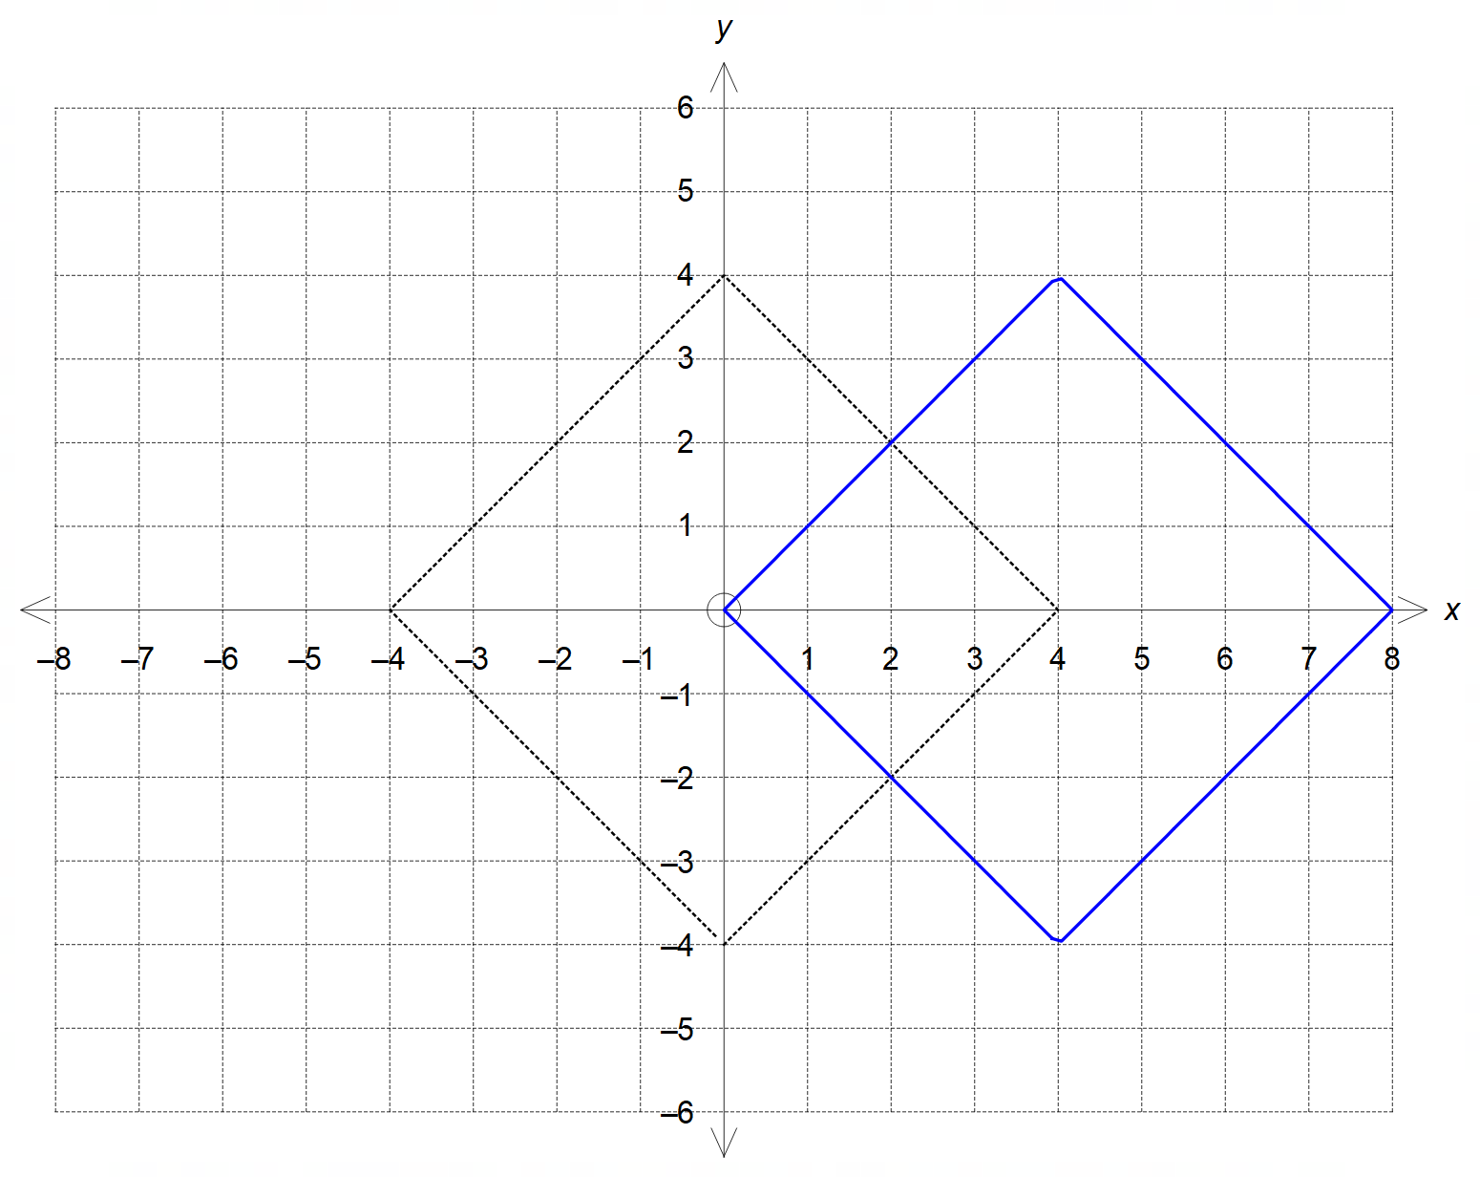12. (a)
shape/accuracy

location

(b) $x^{2}+y^{2}=k$ is a circle and can intersect the square four times at
either its vertices, or use its sides as tangents.
$∴k=16 or k={\left(2\sqrt{2}\right)}^{2}=8$
(c) $n=4 and m>1$ [6]

13. (a) Solution given is $z_{0}=2\operatorname{cis}\left(-\frac{3π}{10}\right)$
$∴a+bi=z_{0}^{5}=2^{5}\operatorname{cis}\left(5×-\frac{3π}{10}\right)=32\operatorname{cis}\left(\frac{π}{2}\right)=0+32i$
$a=0 and b=32$
Other solutions can be graphed and then listed:
$z_{1}=2\operatorname{cis}\left(\frac{π}{10}\right), z_{2}=2\operatorname{cis}\left(\frac{π}{2}\right), z_{3}=2\operatorname{cis}\left(\frac{9π}{10}\right), z_{4}=2\operatorname{cis}\left(-\frac{7π}{10}\right)$

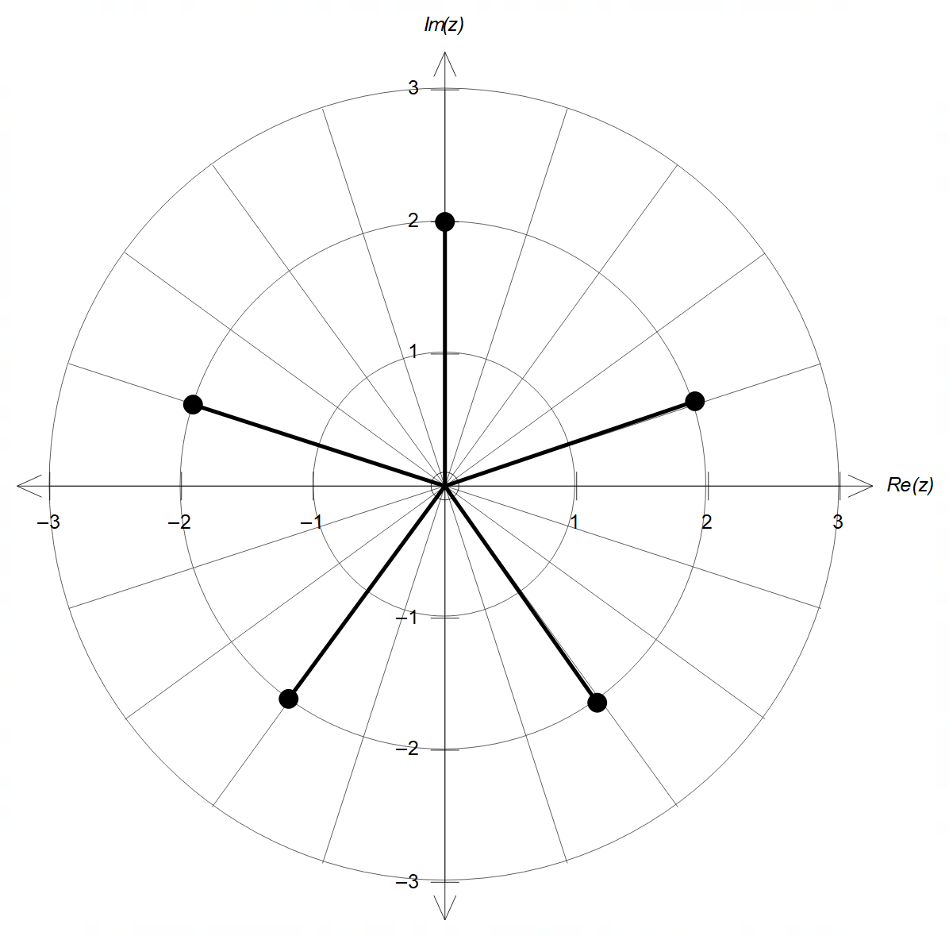

magnitude of 2

$\frac{2π}{5}$ apart (4 div)

13. (b) (i) $-\frac{v}{i}=\frac{-1×v}{i }=\frac{\operatorname{cis}\left(π\right)×3\operatorname{cis}\left(\frac{π}{4}\right)}{\operatorname{cis}\left(\frac{π}{2}\right)}=3\operatorname{cis}\left(\frac{3π}{4}\right)$
(ii) $w-\overline{w}=4\operatorname{cis}\left(-\frac{π}{6}\right)-4\operatorname{cis}\left(\frac{π}{6}\right)=8i\sin\left(-\frac{π}{6}\right)=-4i$
(iii) $v×w^{0.5}=3\operatorname{cis}\left(\frac{π}{4}\right)×2\operatorname{cis}\left(-\frac{π}{12}\right)=6\operatorname{cis}\left(\frac{π}{6}\right)$

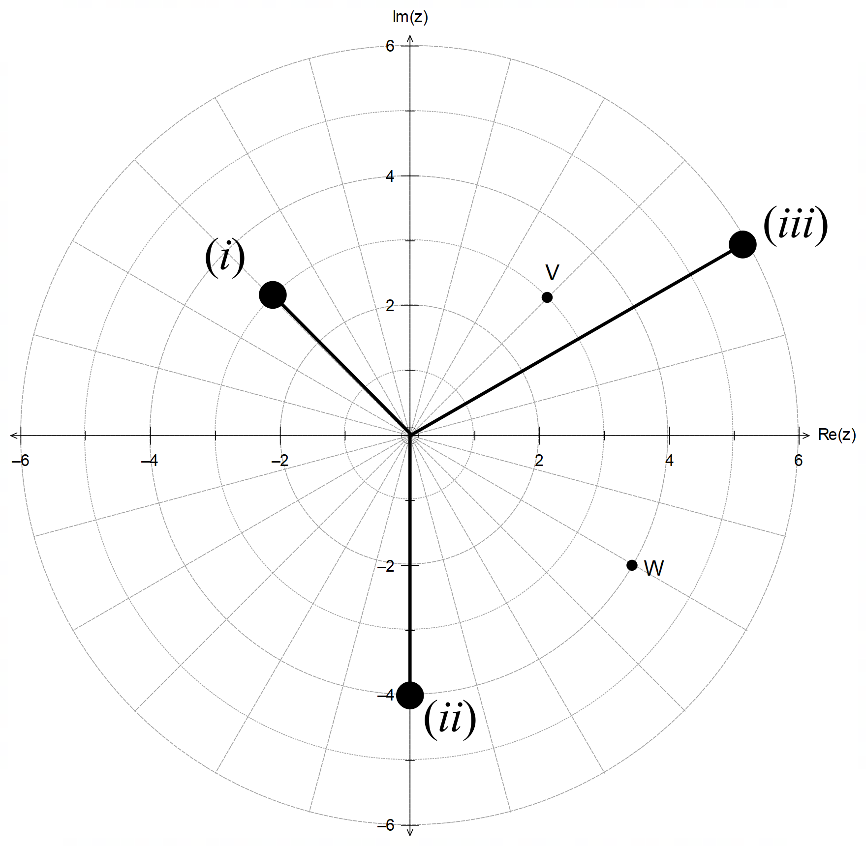
magnitude
argument
(each)

[13]

14. (a) Location of collision:
$\vec{OA}\left(12\right)=\left(\begin{matrix}3 \\ -2 \\ 6\end{matrix}\right)+12\left(\begin{matrix}4 \\ 3 \\ -2\end{matrix}\right)=\left(\begin{matrix}51 \\ 34 \\ -18\end{matrix}\right) m from O$
$\vec{OB}\left(9\right)=\left(\begin{matrix}24 \\ -2 \\ 36\end{matrix}\right)+9\left(\begin{matrix}x \\ y \\ z\end{matrix}\right)=\left(\begin{matrix}51 \\ 34 \\ -18\end{matrix}\right) → \left(\begin{matrix}x \\ y \\ z\end{matrix}\right)=\left(\begin{matrix}3 \\ 4 \\ -6\end{matrix}\right) m/s$
$∴\left|v\right|=\left|\begin{matrix}3 \\ 4 \\ -6\end{matrix}\right|=\sqrt{61}≈7.81 m/s$

(b) Resetting timer/position for particle A;
$\vec{OA}\left(3\right)=\left(\begin{matrix}3 \\ -2 \\ 6\end{matrix}\right)+3\left(\begin{matrix}4 \\ 3 \\ -2\end{matrix}\right)=\left(\begin{matrix}15 \\ 7 \\ 0\end{matrix}\right)$
$∴\vec{OB}=\left(\begin{matrix}24 \\ -2 \\ 36\end{matrix}\right)+t\left(\begin{matrix}x \\ y \\ z\end{matrix}\right)=\left(\begin{matrix}15 \\ 7 \\ 0\end{matrix}\right)+t\left(\begin{matrix}4 \\ 3 \\ -2\end{matrix}\right)=\vec{OA}$

14. (c) $t\left(\begin{matrix}x \\ y \\ z\end{matrix}\right)=\left(\begin{matrix}-9 \\ 9 \\ -36\end{matrix}\right)+t\left(\begin{matrix}4 \\ 3 \\ -2\end{matrix}\right)$ from (b)
$∴x=4-\frac{9}{t} , y=3+\frac{9}{t} and z=-2-\frac{36}{t}$
and $\sqrt{x^{2}+y^{2}+z^{2}}=6$
$∴{\left(4-\frac{9}{t}\right)}^{2}+{\left(3+\frac{9}{t}\right)}^{2}+{\left(2+\frac{36}{t}\right)}^{2}=36$
CAS $→ t=9±\frac{45}{\sqrt{7}} → t≈26 s from t=3$
$∴t=29 s from t=0$
$\vec{OA}\left(29\right)≈\left(\begin{matrix}119 \\ 85 \\ -52\end{matrix}\right) m from O$ [11]

15. (a) $gg\left(x\right)=a^{2}+\frac{1}{\left(a^{2}+\frac{1}{x-a^{2}}\right)-a^{2}}=a^{2}+\frac{1}{\left(\frac{1}{x-a^{2}}\right)}=a^{2}+x-a^{2}=x$
$D_{x}=\left\{x∈R:x≠a^{2}\right\} R_{y}=\left\{y∈R:y≠a^{2}\right\}$
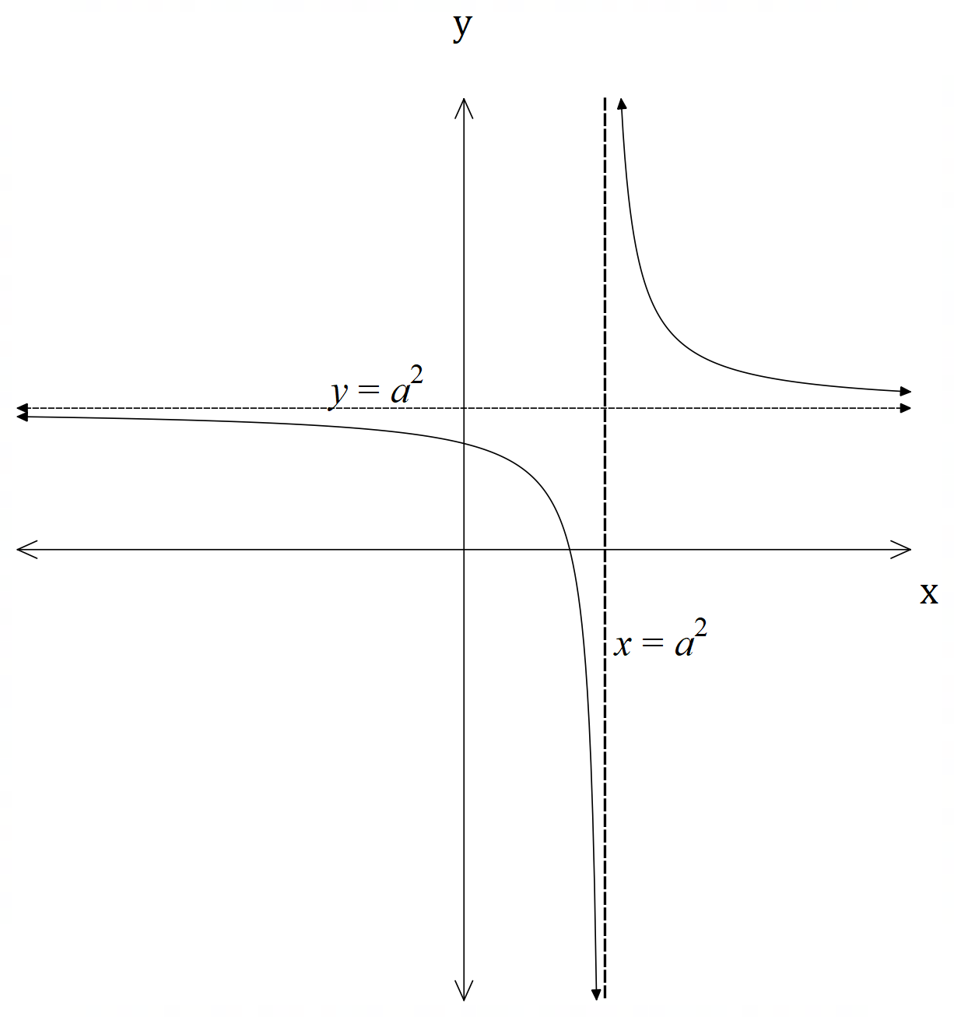 (b)

asymptote $y=a^{2}$

pole $x=a^{2}$

positive rectangular
hyperbola

(c) (i) $h\left(x\right)=2+\frac{1}{x-2}=\frac{2x-3}{x-2} → k=-3$
(ii) $h\left(x\right)$ is an involution and hence it is its own inverse.
The graphs of $h\left(x\right)$ and $h^{-1}\left(x\right)$ are symmetrical over the line $y=x$.
They have the same set for both its domain and range: $x,y≠2$.
They have the same asymptote $x=2$.
They have the same pole $y=2$ [12]
(any four of these)

16. (a) $\sin\left(6θ\right)=Im{\left[\left(\cos\left(2θ\right)+i\sin\left(2θ\right)\right)\right]}^{3}$ from De Moivre’s theorem
CAS $→ \sin\left(6θ\right)=3\cos^{2}\left(2θ\right)\sin\left(2θ\right)-\sin^{3}\left(2θ\right)$
$=3\sin\left(2θ\right)\left[1-\cos^{2}\left(2θ\right)\right]-\sin^{3}\left(2θ\right)$
$=3\sin\left(2θ\right)-4\sin^{3}\left(2θ\right)$
(b) Let $x=\sin{(2θ)}$
$∴3x-4x^{3}=3\sin\left(2θ\right)-4\sin^{3}\left(2θ\right)=\sin\left(6θ\right)=1$ from (a)
$∴6θ=-\frac{3π}{2},\frac{π}{2} → θ=-\frac{π}{4},\frac{π}{12}$
$∴x=\sin\left(2×\frac{-π}{4}\right)=\sin\left(-\frac{π}{2}\right)=-1$
$x=\sin\left(2×\frac{π}{12}\right)=\sin\left(\frac{π}{6}\right)=\frac{1}{2}$ [7]

17. $\left(f∘g\right)\left(x\right)=2g-1=2\left(\frac{x}{2}-4\right)-2=x-9$
$∴{\left(f∘g\right)}^{-1}\left(x\right)=x+9$
$f^{-1}\left(x\right)=\frac{x+1}{2}$ and $g^{-1}\left(x\right)=2x+8$
$∴\left(f^{-1}∘g^{-1}\right)\left(x\right)=\frac{1}{2}g^{-1}+\frac{1}{2}=\frac{1}{2}\left(2x+8\right)+\frac{1}{2}=x+\frac{9}{2}$
$\left(g^{-1}∘f^{-1}\right)\left(x\right)=2f^{-1}+8=2\left(\frac{x+1}{2}\right)+8=x+9$
$∴{\left(f∘g\right)}^{-1}\left(x\right)=\left(g^{-1}∘f^{-1}\right)\left(x\right)$ [6]

